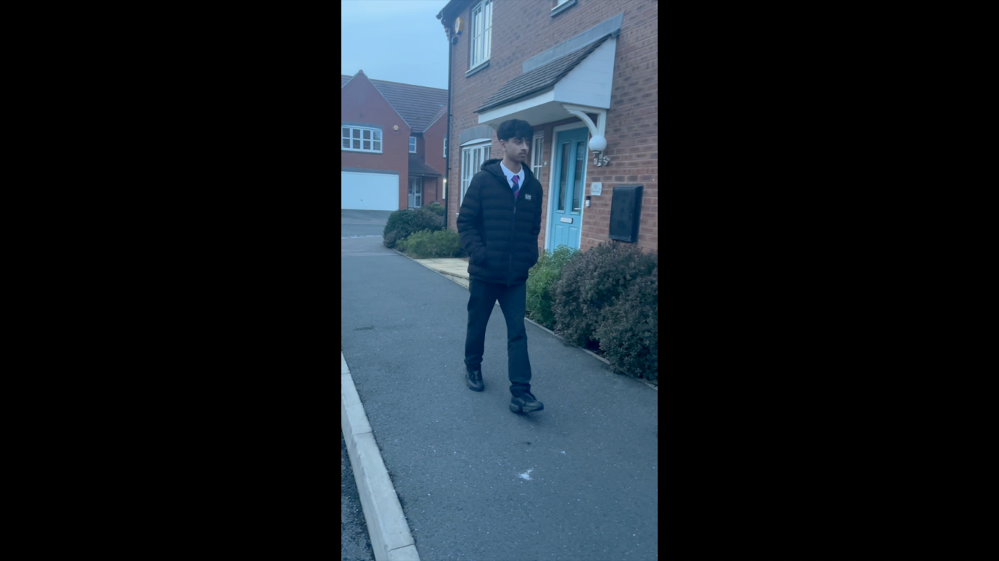Creative Foundations

Element 2 – Video

Escapism (Duration: 58 seconds)